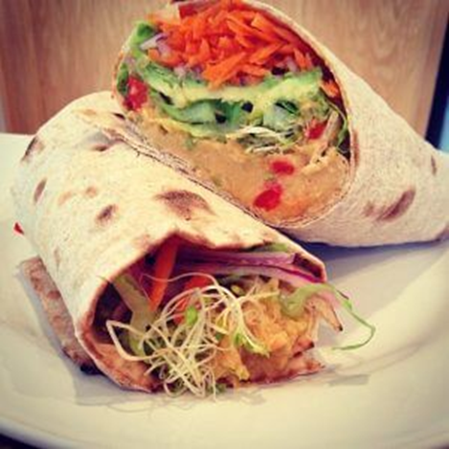Roasted Red Pepper Wraps

|  |
| --- |
| Ingredients With Measurements  * 4 large whole wheat wraps * 2 cups hummus * 2-3 cups shredded lettuce * 2 whole roasted red bell peppers, sliced thinly * 1 cup of grated carrots * 1 avocado, thinly sliced * 1 cup of alfalfa sprouts * 1 red onion, sliced |

|  |
| --- |
| Recipe Lay out each wrap and spread about ¼ or ½ cup hummus on each top near the center so you can roll it up.  Layer the rest of the veggies in the order listed in the ingredients. |

|  |  |  |  |  |  |  |  |  |
| --- | --- | --- | --- | --- | --- | --- | --- | --- |
| |  |  |  | | --- | --- | --- | | Whole Wheat Wraps | Hummus | Shredded Lettuce | | Red Bell Peppers | Carrots | Avocado | | Alfalfa Sprouts | Red Onion |  Ingredients Without Measurements |